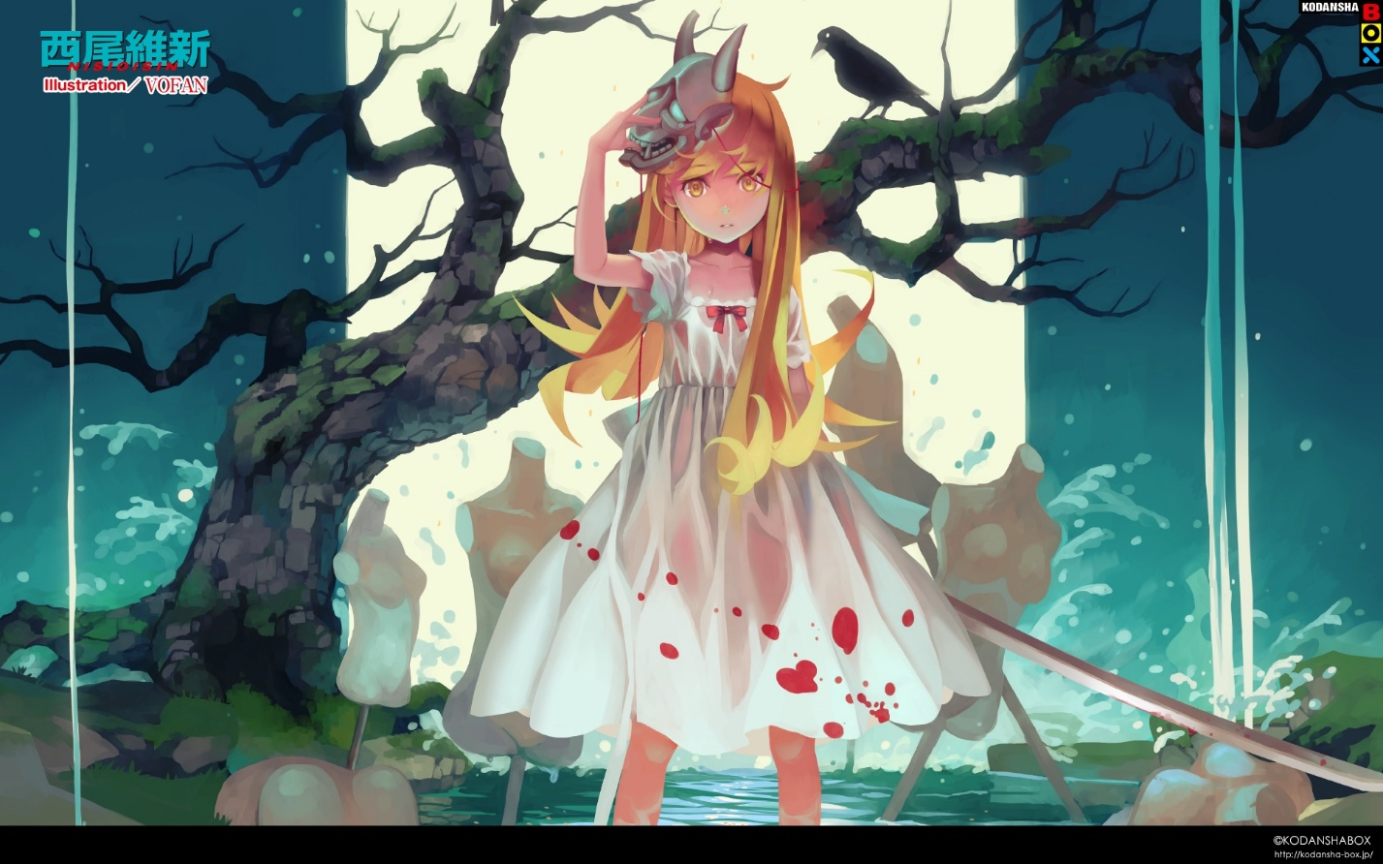Shinobumonogatari

# Shinobu Mustard

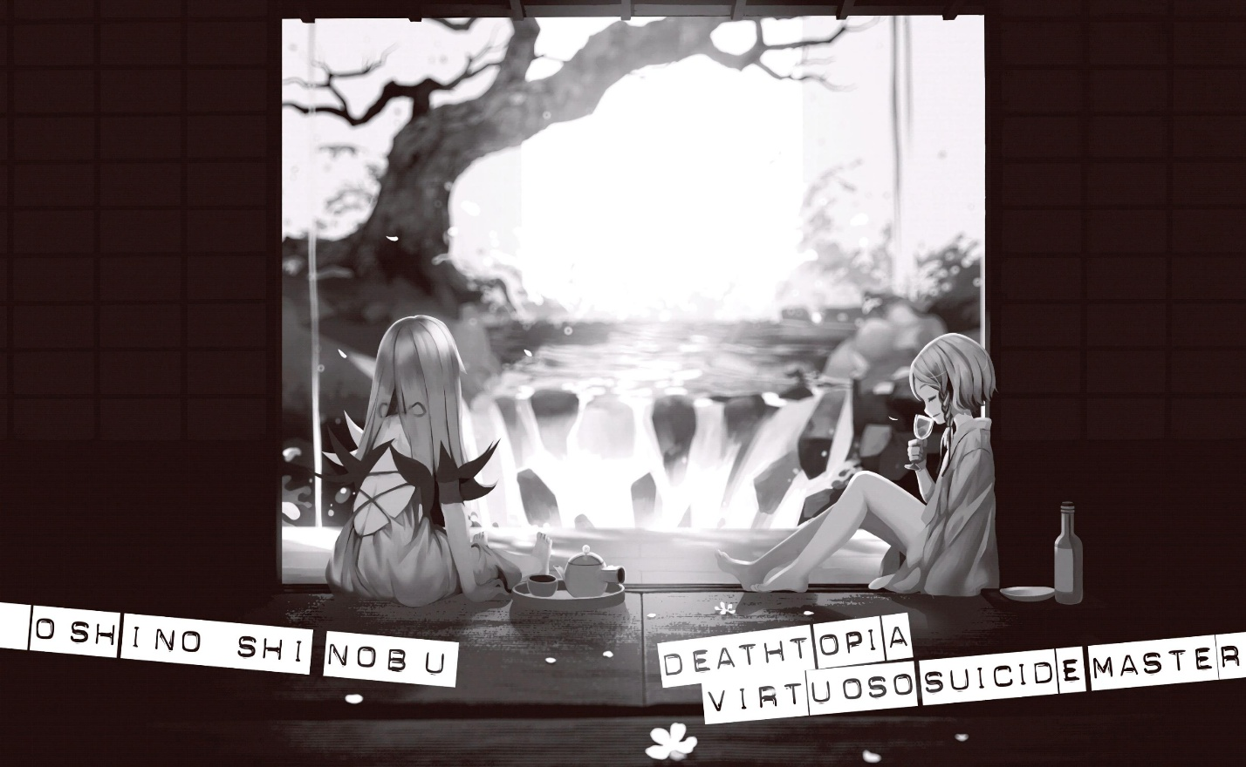Chapter 35

p. 192-198

A six-hundred-year reunion, after a fashion.

Although we had chosen the Kanbaru home for our location, cleaning up my junior’s catastrophically disordered room by sunset would be an impossible task; however, as much as I’d been told I could use the house however I wanted, it wouldn’t do to trespass on her grandma and grandpa’s territory either. As such, we decided to use the Japanese mansion’s garden for the resurrection of Deathtopia Virtuoso Suicide-Master.

Much like in Ryouan-ji, it was a rock garden.(1)

Well, it might have been a last resort, but viewing the mansion from the outside rather than the inside seemed to better convey its castle-like quality.

Yesterday, it felt like I ran out of time and night had fallen before I finished what I was doing; however, today I’d done everything I had to—if I must say, I’d ran out of material—before nightfall.

Now then, what’s going to happen?

“Sorry for the wait. Shall we begin?”

The sun had gone down about halfway when Gaen-san appeared, bottle in hand. Greeting her were myself, Shinobu, who’d woken up early and crawled out of my shadow, Hachikuji, our observer, and the supine Suicide-Master—I couldn’t stand making a bound girl lie down on bare ground, so I’d spread out a rush mat (which I found in Kanbaru’s room; why on earth would she have something like that?).

The actors were all present.

The show must go on.

“Just in case, I erected a barrier around the circumference of the mansion, so even if a battle breaks out it’ll be fine.”

“That’s just the case I’d like to avoid… So, Gaen-san. What is that bottle for?”

“This is more or less within my scope as a specialist too. Wine would be better for a vampire, but in the Japanese style, this is sacred *sake* for a demon.”

Well, I suppose crosses and holy water wouldn’t quite do in a Japanese mansion where a shrine goddess is present… her behavior might suggest she’d come to a midnight drinking party, but it was quite right for where we were.

“If only you’d worn the full formal dress too…”

“Did you want to see me in shrine maiden clothes, Koyomin? Unfortunately, I don’t take formalities and ceremonies as seriously as Meme does. I’m both a pacifist *and* a rationalist.”

Now that I think about it, that middle-aged Hawaiian shirt guy may have seemed careless, but actually, he could be persistent about arrangements and whatnot to the point of illogicality… And looking closely at Gaen-san’s bottle, it seemed to be cheap stuff she’d bought at a discount store… It must be rather difficult to call it sacred *sake*.

Doing what’s difficult is the Gaen way, huh.

“Really, I never thought I’d enter the house that rejected the sister I’m so proud of—karma goes around and around.”

Speaking as if she were amused, Gaen-san casually upended the bottle and poured it over the length of the white-clothed girl’s body.

It seemed less like an occult ceremony and more like a “magic kettle” from rugby.(2)

Thank goodness; judging from her composed behavior, it appeared as though Gaen-san had safely broken free of the sordid quagmire of high school girls.

“Ooh. White clothing getting wet and sticking tightly around a girl’s body, seems kind of erotic, doesn’t it?”

You wouldn’t think Hachikuji much of a goddess from that statement—let me just say, I hadn’t touched on it (double meaning) out of kindness, but when she was bathing in a waterfall for a joke yesterday, she looked the same way.

Setting that aside.

“Hey, Shinobu-sama.”

“…… Huh? Oh, you mean me, my master?”

She’s not getting into her role at all, is she.

Her servile disposition has become rather deeply ingrained.

“I mean, my servant. What is it?”

“Even if you correct it immediately… Well, anyway. Shinobu-sama. My master. Might I be so bold as to inquire something of you?”

“If that’s the quality of acting you take to the real performance, it’ll be your fault if we get found out, you know?”

It’ll be both of our faults, I think.

However, there was no time for a quip, so I continued.

“I haven’t thought about it too deeply until now, but… What’s it like to live for six hundred years?”

“Hmm?”

“I mean, if I may be permitted to speak for myself, thinking back on this past year alone, I feel as though I’ve changed.”

“Speak normally. I have no idea what you’re talking about.”

Hmm.

I had no idea what I was talking about either.

“While you’re living, your opinions change, your feelings change, you realize your mistakes, and you learn the truth, right? *I won’t make friends, because my strength as a human would decrease—*when I used to say things like that, I truly believed them, and I don’t think I could have believed that I’d be able to make friends normally when I went to college.”

That’s just in one year.

If it were six hundred years… How would it feel to look back on your past, then, I’d suddenly wondered.

“Even speaking normally I have no idea what you’re talking about. After all, the past that I can’t fully remember, I throw away.”

Because she couldn’t fully remember it, or because she didn’t want to remember it? Or maybe she doesn’t remember even that.

Well, alright. I’d just tried to find something to say at the last minute; once again, even I had no idea what I was talking about.

Do I want to tell her that there’s no need to make the same decision that she did six hundred years ago just because it’s their first time meeting for six hundred years? But, if Kiss-Shot Acerola-Orion Heart-Under-Blade was on the verge of death in an alley, would I present my neck to her the same way I had a year ago?

“Before oddities are immortal, they’re constant, universal. They’re not always changing like humans are.”

“In that case, I’ll ask you again what I asked you that spring break. Shinobu, what are humans to you?”

When Shinobu Oshino was not yet Shinobu Oshino and still Kiss-Shot Acerola-Orion Heart-Under-Blade, she had answered the question without a second thought.

That they were “food”.

But that’s not correct for the present Shinobu.

It may be obvious that’s because she’s been sealed away, but even bearing that in mind, it still wouldn’t be correct.

But her answer would have to wait—as if aiming for a moment when Shinobu was taken by surprise and had fallen silent, Gaen-san began chanting what sounded like a magic spell that had taken the world by storm several decades previously:

“O devourer, o imbiber, o lurker! The sacred sun has set; now is the time to tear off your coffin-lid and be revived! Boil the flesh in blood, and stir it up with bone!”

It seemed like a joke, but I suppose it was serious.

“Come, alongside the night! Deathtopia Virtuoso Suicide-Master!”

Finally, showing she was aware of how clichéd the incantation sounded, she added, “Or something like that.” However, at that moment, drenched in cheap *sake*, the girl’s supine body radiated a golden color—or so I thought.

It was my imagination. A misunderstanding.

Actually, having slumbered as if dead, she had suddenly opened her eyes wide—the blindfold had popped off, revealing two eyes the same golden color as her hair, and it felt as though they were emitting light.

Until now, Madam Suicide-Master’s face had seemed expressionless, in the vein of Ononoki-chan, but that cleared up when her eyes opened.

They were both blond-haired and golden-eyed, but she felt considerably different from Shinobu.

The *sake* that was sprinkled on her instantly evaporated—the hand- and foot-cuffs, and even the sash from her white clothing, popped off like the blindfold had.

From a distance, I couldn’t tell whether Gaen-san had dispelled the seal or whether the girl herself had dispelled the seal—but since my impression leaned toward the latter, I couldn’t help but think, *How could you call this “weakened”?*

Just when I’d started to feel regretful for my rash acts of medical treatment which had made me recall that spring break, and thinking that maybe we should have left her as a mummy, the girl’s face turned toward me.

Lying down, she rotated just her neck toward me—no.

Those golden eyes weren’t focusing on me, but rather the other girl in this garden, the one standing on my shadow.

The instant she’d awoken, this ancient vampire had sensed her former minion.

Then.

“Ha.”

And.

“Ha.” “Ha.”

And.

“Ha.” “Ha.” “Ha.”

And.

“Ha! Ha ha! Ha ha ha! Ha ha ha ha!  Ha ha ha ha ha ha!” “Ha ha ha ha ha ha ha ha ha ha!” “Ha ha ha ha ha ha ha ha ha ha ha ha ha ha ha!”

Sprawled on the ground, from the absolute lowest position, her laugh rang out louder than I could have imagined.

Receiving that loud laughter, Shinobu bore vivid witness to her old master’s revival.

“Ha.”

And.

“Ha.” “Ha.”

And.

“Ha.” “Ha.” “Ha.”

And.

“Ha! Ha ha! Ha ha ha! Ha ha ha ha!  Ha ha ha ha ha ha!” “Ha ha ha ha ha ha ha ha ha ha!” “Ha ha ha ha ha ha ha ha ha ha ha ha ha ha ha!”

She returned the laugh.

“Ha ha ha ha ha ha ha ha ha ha ha ha ha ha ha ha ha ha ha ha ha ha ha ha ha ha ha ha ha ha ha ha!” “Ha ha ha ha ha ha ha ha ha ha ha ha ha ha ha ha ha ha ha ha ha ha ha ha ha ha ha ha ha ha ha ha!” “Ha ha ha ha ha ha ha ha ha ha ha ha ha ha ha ha ha ha ha ha ha ha ha ha ha ha ha ha ha ha ha ha!” “Ha ha ha ha ha ha ha ha ha ha ha ha ha ha ha ha ha ha ha ha ha ha ha ha ha ha ha ha ha ha ha ha ha ha ha ha ha ha ha ha ha!”

If a barrier hadn’t been put up, their loud exchange of laughter would surely have disturbed the neighborhood—their laughter at each other was as loud as audio feedback from two microphones. I wonder how long it went on for.

As long as six hundred years, or a thousand years.

Could it have gone on forever?

What brought an end to their explosion of laughter, so audacious as to make it seem like me and Gaen-san and Hachikuji weren’t even there, was a brief comment from the girl lying down.

“Somehow or other, it seems I died again.”

Hearing that, Shinobu shrugged her shoulders, and said:

“We’ve both grown old, haven’t we.”

The two girls reunited for the first time in six hundred years.

Footnotes:  
(1) Ryouan-ji is a Zen temple located in Kyoto.  
(2) Apparently, this refers to rugby athletes using a “magic kettle” to wake up teammates who have been tackled and concussed or something.